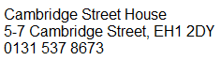

**Oxgangs Library**343 Oxgangs Road North

Edinburgh EH 13 9LY

**Tuesdays**

**1.30 – 4.30pm**

(Last conversation at 4pm)

**_____**

**Space Broomhouse Hub**79-89 Broomhouse Crescent

Edinburgh EH11 3RH

**Fridays**

**9.30am – 1pm**

(Last conversation at 12.30pm)